***Shukersal Deal***

***Version 0***

Table of Contents

Diagrams 2

White Diagram 2

Architecture Diagram 3

Use-Cases 4

I.1 Market initialization 4

I.2. a. Modifying an external service connection 4

I.2. b. Adding an external service connection 5

I.2. c. Removing an external service connection 7

I.3 Process payment via external service 8

I.4 Process delivery via external service 9

I.5/I.6 Receiving a notification. 10

II.1.1 Enter as a guest 11

II.1.2 Logout 11

II.1.3 Sign-Up 12

II.1.4 Login 13

II.2.1 Getting shops and products information 14

II.2.2 Searching products 14

II.2.3 Adding a new item to the basket 15

II.2.4 Removing an item from the basket 16

II.2.5 Purchase a shopping cart 17

Check availability in stock 19

II.3.1 Log-out 20

II.3.2 Opening a store 20

II.3.3/II.3.4 Writing reviews about purchased products or rating the products 21

II.3.5 Sending messages to the store 22

II.3.6 Submitting complaints 23

II.3.7/II.6.4 Browse personal purchase history. 23

II.3.8 Accessing the account details and changing them 24

II.3.9 Upgrading security level 25

II.4.1 Managing the store's inventory 25

II.4.4 Store owner promotes another member to be a new store owner 27

II.4.6 Store owner promotes another member to be a new store manager 28

II.4.7 Store owner changes the permissions of a store manager 29

II.4.9 Store founder closes his store 30

II.4.11 Store owner requests information about the store 30

II.4.13/ II.6.4 Browse shop’s purchase history. 31

Responsibility assignment 33

Glossary of terms 36

# Diagrams

## White Diagram

## Architecture Diagram

# Use-Cases

### I.1 Market initialization

1. ***Actors:*** *User.*
2. ***Post-conditions:***
   1. *A market that compiles all integrity rules was initiated.*
3. ***Actions****:*
   1. *The user enters the market.*
   2. *The user is identified as a guest.*

### I.2. a. Modifying an external service connection

1. ***Actor****: Admin*
2. ***Post-conditions:***
   1. *The connection with the external service is updated.*
3. ***Actions:***
   1. *The admin wants to modify the connection with an external service.*
   2. *The admin enters the external service’s id.*
   3. *The admin selects the field he wants to modify (name, contact number)*
   4. *The admin enters the new name/contact number.*
   5. *A message confirming the modifications is displayed to the admin.*
4. ***Alternatives:***
   1. *A connection to an external service with the entered id doesn’t exist.*
      1. *An informative message is displayed.*
      2. *The modification is aborted.*
   2. *An external service with the new name already exists in the system.*
      1. *An informative message is displayed.*
      2. *The modification is aborted.*
   3. *The modified property is invalid.*
      1. *An informative message is displayed.*
      2. *The modification is aborted.*

***Acceptance Tests***

|  |  |  |
| --- | --- | --- |
| ***Positive/Negative*** | ***Scenario*** | ***Outcome*** |
| ***Positive*** | *The connection to the external service exists, the admin enters a new name that is valid and available.* | * + - * *The connection is updated.*       * *A confirmation message is displayed.* |
| ***Negative*** | *The connection to the external service does not exist.* | * + - * *An informative message is displayed.*       * *The modification is aborted.* |
| ***Negative*** | *The connection to the external service exists, the new contact number is too short.* | * + - * *An informative message is displayed.*       * *The modification is aborted.* |
| ***Negative*** | *The connection to the external service exists, the admin enters a new name that is valid but is taken by another external service.* | * + - * *An informative message is displayed.*       * *The modification is aborted.* |

### I.2. b. Adding an external service connection

1. ***Actor:*** *Admin*
2. ***Post-conditions:***
   1. *The connection with the external service is added.*
3. ***Actions:***
   1. *The admin wants to add a connection with an external service.*
   2. *The admin selects between payment and delivery service.*
   3. *The admin enters the name and contact number.*
   4. *A message confirming the addition is displayed to the admin.*
4. ***Alternatives:***
   1. *An external service with the entered name already exists in the system.*
      1. *An informative message is displayed.*
      2. *The modification is aborted.*
   2. *The name/contact number is invalid.*
      1. *An informative message is displayed.*
      2. *The modification is aborted.*

***Acceptance Tests***

|  |  |  |
| --- | --- | --- |
| ***Positive/Negative*** | ***Scenario*** | ***Outcome*** |
| ***Positive*** | *The admin selects to add a connection to an external delivery service, the name and contact number are valid, the name is available.* | * + - * *The connection is added.*       * *A confirmation message is displayed.* |
| ***Negative*** | *The admin selects to add a connection to an external delivery service, the name is blank.* | * + - * *An informative message is displayed.*       * *The addition is aborted.* |
| ***Negative*** | *The admin selects to add a connection to an external delivery service, the name and contact number are valid, but another connection with the same name already exists.* | * + - * *An informative message is displayed.*       * *The modification is aborted.* |

### I.2. c. Removing an external service connection

1. ***Actor****: Admin*
2. ***Post-conditions:***
3. *The connection with the external service is removed.*
4. ***Actions:***
5. *The admin wants to remove a connection with an external service.*
6. *The admin enters the external service’s id.*
7. *A message confirming the addition is displayed to the admin.*
8. ***Alternatives:***
9. *An external service with the entered id doesn’t exist in the system.*
10. *An informative message is displayed.*
11. *The modification is aborted.*
12. *The connection is to the only delivery/payment service available in the system.*
13. *An informative message is displayed.*
14. *The modification is aborted.*

***Acceptance Tests***

|  |  |  |
| --- | --- | --- |
| ***Positive/Negative*** | ***Scenario*** | ***Outcome*** |
| ***Positive*** | *The id of the delivery service exists, and it is not the only delivery service available in the system.* | * + - * *The connection is removed.*       * *A confirmation message is displayed.* |
| ***Negative*** | *The id of the delivery service doesn’t exist in the system.* | * + - * *An informative message is displayed.*       * *The addition is aborted.* |
| ***Negative*** | *The id of the delivery service exists but it is the only delivery service available in the system.* | * + - * *An informative message is displayed.*       * *The modification is aborted.* |

### I.3 Process payment via external service

1. ***Actors:*** *External payment system.*
2. ***Pre-conditions****:*
3. *A shipping is confirmed.*
4. ***Post-conditions:***
5. *The payment was made.*
6. ***Parameters****: Transaction details (amount, credit card number, expiration date, cvc, full name and Id of the card’s holder), payment service id.*
7. ***Actions****:*
8. *The System approaches the external payment service.*
9. *The referral includes the transaction details.*
10. *The External payment service returns confirmation that the payment was successful.*
11. ***Alternatives****:*
12. *The billing failed.*
13. *The billing is aborted.*
14. *The external system rejects the payment.*

***Acceptance Tests***

|  |  |  |
| --- | --- | --- |
| ***Positive/Negative*** | ***Scenario*** | ***Outcome*** |
| ***Positive*** | *The billing succeeded.* | * + - * *The payment was made.*       * *The external payment service returns a confirmation that the payment was successful.* |
| ***Negative*** | *The billing failed.* | * + - * *The payment was aborted.*       * *The external system rejects the payment.* |

### I.4 Process delivery via external service

1. ***Actors****:**External delivery system****.***
2. ***Pre-conditions****:*
3. *The user has at least one item in his cart.*
4. ***Post-conditions:***
5. *The delivery was confirmed.*
6. ***Parameters****: Delivery details (receiver’s full name, phone number, address, and postal code), items to be delivered, delivery service id.*
7. ***Actions****:*
8. *The System approaches the external delivery service.*
9. *The referral includes the delivery details.*
10. *The External delivery service returns a confirmation that the delivery is possible.*
11. ***Alternatives****:*
12. *The delivery is not possible.*
13. *The external system declines the delivery.*

***Acceptance Tests***

|  |  |  |
| --- | --- | --- |
| ***Positive/Negative*** | ***Scenario*** | ***Outcome*** |
| ***Positive*** | *The delivery was approved.* | * + - * *The external delivery service returns a confirmation that the delivery is possible.* |
| ***Negative*** | *The delivery was not possible.* | * + - * *The external system rejects the delivery.* |

### I.5/I.6 Receiving a notification.

1. ***Actor:*** *Member*
2. ***Pre-conditions****:*
3. *An event that concerns the member occurred.*
4. ***Post-conditions:***
5. *The member received the notification.*
6. ***Actions****:*
7. *The member was visiting the market at the time the event occurred.*
8. *The member is alerted by the real time notification and can read its content.*
9. ***Alternatives:***
10. *The member was not visiting the market at the time the event occurred.*
11. *The member will receive the halted notification the next time he logs in to the market.*

***Acceptance Tests***

|  |  |  |
| --- | --- | --- |
| ***Positive/Negative*** | ***Scenario*** | ***Outcome*** |
| ***Positive*** | *The member is the owner of a shop from which a customer purchased an item.*  *The member is logged in at the time of the purchase.* | * + - * *The member gets a real time notification which notifies him of the purchase* |
| ***Negative*** | *The member is the owner of a shop from which a customer purchased an item.*  *The member is not logged in at the time of the purchase.* | * + - * *The member gets a halted notification which will notify him of the purchase the next time he logs in to the market.* |

### II.1.1 Enter as a guest

1. ***Actor:*** *User*
2. ***Post-conditions:***
3. *The user is identified as a guest.*
4. ***Actions****:*
5. *A user wants to enter the market.*

***Acceptance Tests***

|  |  |  |
| --- | --- | --- |
| ***Positive/Negative*** | ***Scenario*** | ***Outcome*** |
| ***Positive*** | *The user is unsigned when the user tries to enter as a guest* | * + - * *The user is identified as a guest* |
| ***Negative*** | *The user is logged in as a guest or a member when the user tries to enter as a guest* | * + - * *An informative message is displayed.* |

### II.1.2 Logout

1. ***Actor:*** *Member*
2. ***Pre-conditions****:*
3. *The member is logged in.*
4. ***Post-conditions:***
5. *The member is logged out and is recognized as a guest.*
6. ***Actions****:*
7. *The member wants to log out from the system.*

***Acceptance Tests***

|  |  |  |
| --- | --- | --- |
| ***Positive/Negative*** | ***Scenario*** | ***Outcome*** |
| ***Positive*** | *The member is logged in.* | * + - * *The member is logged out and recognized as a guest* |
| ***Negative*** | *The member is not logged in.* | * + - * *An informative message is displayed.* |

### II.1.3 Sign-Up

1. ***Actor:*** *Guest*
2. ***Pre-conditions****:*
3. *The user is a guest (not a member).*
4. ***Post-conditions:***
5. *The guest is registered to the market.*
6. *The guest is logged in to the market and is recognized as a member.*
7. ***Parameters:*** *Username, password.*
8. ***Actions****:*
9. *The username is available.*
10. *The new member has the shopping cart and purchases the guest had with the username and password inserted.*
11. *The guest is recognized as a member.*
12. ***Alternatives:***
13. *Found the same username in the market as inserted.*
14. *Display an error message.*

***Acceptance Tests***

|  |  |  |
| --- | --- | --- |
| ***Positive/Negative*** | ***Scenario*** | ***Outcome*** |
| ***Positive*** | *The member is a guest* | * + - * *A new member is created.* |
| ***Negative*** | *The member is logged in* | * + - * *An informative message is displayed.* |
| ***Negative*** | *The username already used* | * + - * *An informative message is displayed.* |

### II.1.4 Login

1. ***Actor:*** *Guest*
2. ***Pre-conditions:***
3. *The guest is not logged in.*
4. ***Post-conditions:***
5. *The guest is logged in and is recognized as a member.*
6. ***Parameters:*** *Username, password.*
7. ***Actions****:*
8. *The guest wants to log in to the market.*
9. *The password matches the username.*
10. ***Alternatives:***
11. *Failed to find a member with the given username/ the password doesn’t match to the username.*
12. *Display an error message.*

***Acceptance Tests***

|  |  |  |
| --- | --- | --- |
| ***Positive/Negative*** | ***Scenario*** | ***Outcome*** |
| ***Positive*** | *The user is a guest and there is a member with the same username and password* | * + - * *The guest is now recognized as a member.* |
| ***Negative*** | *The member is logged in* | * + - * *An informative message is displayed.* |
| ***Negative*** | *The username and the password are not matching* | * + - * *An informative message is displayed.* |

### II.2.1 Getting shops and products information

1. ***Actor:*** *User*
2. ***Actions****:*
3. *Get all the stores and their products.*

***Acceptance Tests***

|  |  |  |
| --- | --- | --- |
| ***Positive/Negative*** | ***Scenario*** | ***Outcome*** |
| ***Positive*** | *The user viewed the shop list* | * + - * *List of all shops and their products is shown.* |

### II.2.2 Searching products

1. ***Actor:*** *User*
2. ***Parameters:*** *Search string, list of constraints*
3. ***Actions****:*
4. *Get all products from every store.*
5. *For each constraint, remove the irrelevant product.*
6. *Search for products that the search string is their category/ their name/ part of their name.*
7. *Return the result to the user.*

***Acceptance Tests***

|  |  |  |
| --- | --- | --- |
| ***Positive/Negative*** | ***Scenario*** | ***Outcome*** |
| ***Positive*** | *The user searched a product that has the same name as inserted* | * + - * *The product is shown up* |
| ***Positive*** | *The user searched a product that its name contains the search string* | * + - * *The product is shown up* |
| ***Positive*** | *The user searched a product that has the same category as inserted* | * + - * *The product is shown up* |
| ***Negative*** | *The user searched a product that doesn't exists* | * + - * *“No product found” message is displayed.* |
| ***Negative*** | *The user searched a product that is rejected by the filters* | * + - * *“No product found” message is displayed.* |

### II.2.3 Adding a new item to the basket

1. ***Actors:*** *User*
2. ***Post-conditions:***
3. *An item with a given ID is added to the shop’s basket that belongs to the User.*
4. ***Parameters:*** *Item ID number, shop ID number*
5. ***Actions:***
6. *User: Choose an item from the shop list*
7. *System: Add the item’s ID into the corresponding shop basket.*

***Acceptance Tests***

|  |  |  |
| --- | --- | --- |
| ***Positive/Negative*** | ***Scenario*** | ***Outcome*** |
| ***Positive*** | *Try to add an item from an existing shop into the shop basket of the actor.* | * + - * *The item is added to the shop’s basket that belongs to the user.* |
| ***Negative*** | *Try to add an item from an existing shop into the shop basket of another (not the actor) user.* | * + - * *The item is not added to the basket.* |

### II.2.4 Removing an item from the basket

1. ***Actors:*** *User*
2. ***Pre-conditions:***
3. *User has at least one non-empty shop basket.*
4. ***Post-conditions:***
5. *An item with a given ID is removed from the shop’s basket that belongs to the User.*
6. ***Parameters:*** *Item ID number, shop ID number*
7. ***Actions:***
8. *User: Choose an item from the shop basket.*
9. *System: Remove the item from the corresponding shop basket.*
10. ***Alternatives:***
11. *The item is not in the basket.*
12. *Display an error message.*

***Acceptance Tests***

|  |  |  |
| --- | --- | --- |
| ***Positive/Negative*** | ***Scenario*** | ***Outcome*** |
| ***Positive*** | *Try to remove an item from the actor’s basket* | * + - * *The item is removed* |
| ***Negative*** | *Try to remove an item not from the actor’s basket* | * + - * *An error message is displayed.* |
| ***Negative*** | *Try to remove an item not from the actor’s basket* | * + - * *An error message is displayed.* |

### II.2.5 Purchase a shopping cart

1. ***Actor:*** *User*
2. ***Pre-Conditions****:*
3. *The user has at least one item in his shopping cart*
4. ***Post-Conditions:***
5. *The user’s shopping cart is empty.*
6. *The shops’ inventory is updated.*
7. *The purchase is documented in the user’s and in the shop’s purchase history.*
8. ***Parameters:*** *Shopping cart, user id, delivery details (receiver’s full name, phone number, address, and postal code) and billing details (credit card number, expiration date, cvc, full name and Id of the card’s holder).*
9. ***Actions****:*
10. *The user wants to purchase the items in his shopping cart.*
11. *For each shopping basket in the shopping cart:*
12. *The system verifies that the purchase policy of the store is adhered to.*
13. *The system verifies that the quantity of each item in the basket doesn’t exceed the amount in stock. (See Check availability in stock)*
14. *The system displays both full and final prices of the items in the shopping basket according to the store’s discount policy.*
15. *The system displays the total price of the purchase.*
16. *The system approaches an external payment service.*
17. *The shipping is confirmed by the delivery service.*
18. *The system approaches an external payment service.*
19. *The payment is confirmed by the payment service.*
20. *For each shopping basket in the shopping cart:*
21. *The appropriate store’s inventory is updated.*
22. *The system notifies the appropriate shop’s owners that items were purchased from their shop.*
23. *The system displays a purchase confirmation message to the user.*
24. *The seller receives his payment.*
25. *The shopping cart is emptied.*
26. ***Alternatives:***
27. *At least one of the shopping baskets doesn’t follow the purchase policy of the appropriate store.*
28. *An informative message is displayed to the user.*
29. *The purchase is canceled.*
30. *At least one of the items in the cart is out of stock.*
31. *An informative message is displayed to the user.*
32. *The purchase is canceled.*
33. *The shipping is not confirmed by the external delivery service.*
34. *An informative message is displayed to the user.*
35. *The purchase is canceled.*
36. *The payment is rejected by the external payment service.*
37. *An informative message is displayed to the user.*
38. *The purchase is canceled.*

***Acceptance Tests***

|  |  |  |
| --- | --- | --- |
| ***Positive/Negative*** | ***Scenario*** | ***Outcome*** |
| ***Positive*** | *All the baskets in the shopping cart adhered to the appropriate shop’s purchase policy, all the items are in stock, the shipping and payment are confirmed.* | * + - * *The purchase is confirmed and documented.*       * *The shop owners are notified about the purchase.*       * *The shops’ inventory is updated.*       * *The user’s shopping cart is empty.* |
| ***Negative*** | *One of the baskets in the cart doesn’t follow the purchase policy of the appropriate store, all the items are in stock.* | * + - * *An informative message is displayed.*       * *The purchase is canceled.* |
| ***Negative*** | *All the baskets in the shopping cart adhered to the appropriate shop’s purchase policy, one of the items in the cart is out of stock.* | * + - * *An informative message is displayed.*       * *The purchase is canceled.* |

#### Check availability in stock

1. ***Actors:*** *Store owner*
2. ***Pre-conditions:***
3. *The store owner has inventory management permissions over the specified store.*
4. ***Parameters:*** *Store id, a list of products and the desired quantities.*
5. ***Actions:***
6. *For each product:*
7. *The system checks if the quantity in stock is equal to or greater than the desired quantity.*
8. *The system confirms that all the listed products are available.*
9. ***Alternatives:***
10. *At least one of the items in the cart is out of stock.*
11. *An informative message is displayed to the store owner.*

### II.3.1 Log-out

1. ***Actors:*** *Member*
2. ***Post conditions****: The member is not logged in.*
3. ***Actions:***
4. *Member: Logs out of the system*

***Acceptance Tests***

|  |  |  |
| --- | --- | --- |
| ***Positive/Negative*** | ***Scenario*** | ***Outcome*** |
| ***Positive*** | *Member logs out* | * + - * *The member is not logged in.* |
| ***Negative*** | *A user that did not log in logs out* | * + - * *The log-out fails.* |

### II.3.2 Opening a store

1. ***Actors:*** *Member, System*
2. ***Post-conditions:***
3. *The new store is opened with the member as its founder.*
4. ***Parameters:*** *Unique (unused) store name*
5. ***Actions:***
6. *Member: Opens a store.*
7. *The system grants the user the shop founder permissions for the store he opened.*

***Acceptance Tests***

|  |  |  |
| --- | --- | --- |
| ***Positive/Negative*** | ***Scenario*** | ***Outcome*** |
| ***Positive*** | *Member opens a store* | * + - * *The system grants the user the shop founder permissions for the store he opened.* |
| ***Negative*** | *The member opens a store with the name that is already used* | * + - * *The store opening fails.* |

### II.3.3/II.3.4 Writing reviews about purchased products or rating the products

1. ***Actors:*** *Member*
2. ***Pre-conditions:***
3. *The member has bought at least one item.*
4. ***Post-conditions:***
5. *The item receives a review written by the user.*
6. ***Parameters:*** *item ID number, shop ID number*
7. ***Actions:***
8. *Member: Chooses an item from bought items*
9. *Member: Writes a review for this item and sends it or rates it*
10. ***Alternatives:***
11. *Member rates one of the items he bought.*
12. *Member writes a review for an item he didn’t receive.*

***Acceptance Tests***

|  |  |  |
| --- | --- | --- |
| ***Positive/Negative*** | ***Scenario*** | ***Outcome*** |
| ***Positive*** | *Member writes a review for one of the items he bought* | * + - * *The reviewing is successful.* |
| ***Negative*** | *Member sends an empty review* | * + - * *The reviewing fails.* |

### II.3.5 Sending messages to the store

1. ***Actors:*** *Member*
2. ***Post conditions:***
3. *The shop management staff can access the message sent by the Member.*
4. ***Parameters:*** *Shop ID number*
5. ***Actions:***
6. *Member: Chooses a shop*
7. *Member: Sends a message to the shop*
8. ***Alternatives:***
9. *User writes a message to a closed store.*
10. *An informative error message Is displayed.*

***Acceptance Tests***

|  |  |  |
| --- | --- | --- |
| ***Positive/Negative*** | ***Scenario*** | ***Outcome*** |
| ***Positive*** | *User sends a message to a store* | * + - * *The message is received by the store's owners.* |
| ***Negative*** | *User sends an empty message* | * + - * *An informative error message Is displayed* |

### II.3.6 Submitting complaints

1. ***Actors:*** *Member*
2. ***Pre-conditions:***
3. *The member made at least one order.*
4. ***Post-conditions:***
5. *The administrator receives a complaint from the member.*
6. ***Parameters:*** *order ID number, complain text*
7. ***Actions:***
8. *Member: Submits a complaint regarding an order the member made.*
9. *System: Sends the complaint to the administrator.*

***Acceptance Tests***

|  |  |  |
| --- | --- | --- |
| ***Positive/Negative*** | ***Scenario*** | ***Outcome*** |
| ***Positive*** | *Member sends a complaint regarding an order he made* | * + - * *The administrator receives a complaint from the member.* |
| ***Negative*** | *Member sends a complaint regarding an order he didn't make (illegal order ID)* | * + - * *An informative error message Is displayed* |

### II.3.7/II.6.4 Browse personal purchase history.

1. ***Actors:*** *Member*
2. ***Parameters:*** *Member’s id*
3. ***Actions:***
4. *The member wants to browse his purchase history.*
5. *The system displays the member’s purchase history.*

***Acceptance Tests***

|  |  |  |
| --- | --- | --- |
| ***Positive/Negative*** | ***Scenario*** | ***Outcome*** |
| ***Positive*** | *The member has previous purchases.* | * + - * *A list of the member’s previous purchases is displayed.* |
| ***Negative*** | *The member doesn’t have previous purchases.* | * + - * *An empty list is presented to the member.* |

### II.3.8 Accessing the account details and changing them

1. ***Actors:*** *Member*
2. ***Post-conditions:***
3. *Member’s account details are changed (optional)*
4. ***Parameters:*** *new account details(optional)*
5. ***Actions:***
6. *Member: checks his account details*
7. ***Alternatives:***
8. *Member: makes changes to the account details*

***Acceptance Tests***

|  |  |  |
| --- | --- | --- |
| ***Positive/Negative*** | ***Scenario*** | ***Outcome*** |
| ***Positive*** | *Member checks his account details.* | * + - * *The member’s account details are displayed.* |
| ***Positive*** | *Member updates his account details* | * + - * *Member’s account details are changed* |
| ***Negative*** | *Member updates his account details with illegal data.* | * + - * *An informative error message Is displayed* |

### II.3.9 Upgrading security level

1. ***Actors:*** *Member*
2. ***Pre-conditions:***
3. *The member’s account’s security level is not maximal.*
4. ***Post-conditions:***
5. *The security level of the member's account is upgraded.*
6. ***Parameters:*** *Security questions and answers to them*
7. ***Actions:***
8. *Member: Upgrades his account security level and provides security questions and answers*

***Acceptance Tests***

|  |  |  |
| --- | --- | --- |
| ***Positive/Negative*** | ***Scenario*** | ***Outcome*** |
| ***Positive*** | *Member upgrades the account security level* | * + - * *The security level of the member's account is upgraded.* |

### II.4.1 Managing the store's inventory

1. ***Actors:*** *Store owner*
2. ***Pre-conditions:***
3. *The store owner has inventory management permissions over the specified store.*
4. ***Post-conditions:***
5. *The store's inventory is up to date.*
6. ***Parameters:*** *Store id*
7. ***Actions:***
8. *If the store owner wants to add a new product:*
   * 1. *The store owner enters the new product's name, serial number, description, price, and quantity.*
     2. *The system adds the new product to the list of available products of the store.*
     3. *A message confirming the addition is displayed.*
9. *If the store owner wants to modify a product's details.*

*The store owner enters the product's serial number.*

* + 1. *The store owner enters a new name/description/price.*
    2. *The product's details are updated.*
    3. *A message confirming the modification is displayed.*

1. *If the store owner wants to remove a product.*
   * 1. *The store owner enters the product's serial number.*
     2. *The product is removed.*
     3. *A message confirming the removal is displayed.*
2. ***Alternatives:***
3. *If one of the following occurs:*
   * 1. *The store owner enters a blank name/ description.*
     2. *The store owner enters a serial number that belongs to another product.*
     3. *The store owner enters a price which is equal to 0 or negative.*
     4. *The store owner enters a negative quantity.*
     5. *A product with the entered serial number doesn’t exist.*
        1. *An informative message is displayed.*
        2. *The operation is aborted.*

***Acceptance test:***

|  |  |  |
| --- | --- | --- |
| ***Positive/Negative*** | ***Scenario*** | ***Outcome*** |
| ***Positive*** | *The store owner wants to add a new product, he enters valid name, serial number, description, price, and quantity.* | * + - * *The new product is added to the store's inventory.*       * *A message that confirms the addition is displayed.* |
| ***Negative*** | *The store owner wants to add a new product, he enters valid name, serial number, description and price he enters a negative number as quantity.* | * + - * *An informative message is displayed.*       * *The operation is aborted.* |

### II.4.4 Store owner promotes another member to be a new store owner

1. ***Actors:*** *Store owner, Member*
2. ***Pre-conditions:***
3. *The store owner is logged in and the member is registered.*
4. ***Post-conditions:***
5. *The member becomes a new shop owner under the original shop owner.*
6. ***Parameters:*** *Member id*
7. ***Actions:***
8. *The owner promotes another member to be a new shop owner.*
9. *The member confirms his promotion.*

***Acceptance test:***

|  |  |  |
| --- | --- | --- |
| ***Positive/Negative*** | ***Scenario*** | ***Outcome*** |
| ***Positive*** | *Store owner promotes a registered member to be a new store owner at his store* | * + - * *The member becomes a new shop owner under the original shop owner* |
| ***Negative*** | *Store owner tries to promote an unregistered member to be a new store owner at his store.* | * + - * *An informative message is displayed.* |

### II.4.6 Store owner promotes another member to be a new store manager

1. ***Actors:*** *Store owner, Member*
2. ***Pre-conditions:***
3. *The store owner is logged in and the member is registered.*
4. ***Post-conditions:***
5. *The member becomes a new shop manager under the original shop owner.*
6. ***Parameters:*** *Member id.*
7. ***Actions:***
8. *The owner promotes another member to be a new store manager.*
9. *The member confirms his promotion.*
10. ***Alternatives:***
11. *The shop owner is notified that the member is not registered.*

***Acceptance test:***

|  |  |  |
| --- | --- | --- |
| ***Positive/Negative*** | ***Scenario*** | ***Outcome*** |
| ***Positive*** | *The store owner promotes a registered member to be a new store manager at his store.* | * + - * *The member becomes a new shop manager under the original shop owner.* |
| ***Negative*** | *The store owner tries to promote an unregistered member to be a new store manager at his store* | * + - * *The shop owner is notified that the member is not registered.* |

### II.4.7 Store owner changes the permissions of a store manager

1. ***Actors:*** *Store owner, Store manager*
2. ***Pre-conditions:***
3. *The store owner logged in.*
4. *The manager was promoted by the store owner or by someone that was promoted by the store owner.*
5. ***Post conditions:***
6. *The manager's permissions are changed according to owner changes.*
7. ***Parameters:*** *Manager id.*
8. ***Actions:***
9. *The owner changes the permissions of a manager who is under him.*
10. ***Alternatives:***
11. *The shop owner is notified that he cannot change the manager's permissions.*

***Acceptance Tests***

|  |  |  |
| --- | --- | --- |
| ***Positive/Negative*** | ***Scenario*** | ***Outcome*** |
| ***Positive*** | *The store owner changes the permissions of a store manager who is under his responsibility.* | * + - * *The manager's permissions are changed according to owner changes.* |
| ***Negative*** | *The store owner tries to change the permissions of a store manager who is not under his responsibility.* | * + - * *The shop owner is notified that he cannot change the manager's permissions.* |

### II.4.9 Store founder closes his store

1. ***Actors:*** *Store founder*
2. ***Pre-conditions:***
3. *The store founder is the member who opened the store in the system.*
4. ***Post conditions:***
5. *The shop is closed, and members of the system cannot view it.*
6. ***Parameters:*** *Store id.*
7. ***Actions:***
8. *The founder closes the shop.*
9. *All the shop owners and managers are notified.*
10. ***Alternatives:***
11. *The shop owner is notified that he cannot close the shop.*

***Acceptance Tests***

|  |  |  |
| --- | --- | --- |
| ***Positive/Negative*** | ***Scenario*** | ***Outcome*** |
| ***Positive*** | *The store founder closes his shop.* | * + - * *The shop is closed, and members of the system cannot view it.* |
| ***Negative*** | *The store owner (who is not the founder) tries to close the shop.* | * + - * *The shop owner is notified that he cannot close the shop.* |

### II.4.11 Store owner requests information about the store

1. ***Actors:*** *Store owner*
2. ***Pre-conditions:***
3. *The store owner is logged in.*
4. ***Post conditions:***
5. *The store owner gets all the information that he asked for.*
6. ***Parameters:*** *Store id.*
7. ***Actions:***
8. *The store owner views all the workers (store owners and managers) in the store.*
9. *The store owner views the permissions that store managers have.*
10. ***Alternative:***
11. *The member is notified that he cannot view the information.*

***Acceptance Tests***

|  |  |  |
| --- | --- | --- |
| ***Positive/Negative*** | ***Scenario*** | ***Outcome*** |
| ***Positive*** | *The store owner requests to view the information.* | * + - * *The store owner gets all the information that he asked for.* |
| ***Negative*** | *Regular members request to view the information.* | * + - * *The member is notified that he cannot view the information.* |

### II.4.13/ II.6.4 Browse shop’s purchase history.

1. ***Actors:*** *Seller/Admin*
2. ***Pre-conditions****:*
3. *The seller has browsing permissions over the shop’s purchase history.*
4. *A shop with the given id exists.*
5. ***Parameters:*** *Shop id*
6. ***Actions****:*
7. *The admin/seller wants to browse the purchase history of the shop.*
8. *The system presents the shop’s purchase history to the seller/admin.*
9. ***Alternatives:***
10. *The shop doesn’t have previous purchases.*
    * 1. *An empty list is presented to the seller/admin.*

***Acceptance Tests***

|  |  |  |
| --- | --- | --- |
| ***Positive/Negative*** | ***Scenario*** | ***Outcome*** |
| ***Positive*** | *The seller has browsing permissions over the shop’s purchase history which contains at least one purchase record.* | * + - * *A list of the shop’s previous purchases is displayed to the seller.* |
| ***Negative*** | *The seller has browsing permissions over the shop’s purchase history, but the shop doesn’t have any previous purchases.* | * + - * *An empty list is presented to the seller.* |

# 

# Responsibility assignment

1. *The constraint is enforced in the use case:* ***II.1.3 Sign-Up.***
2. *The constraint is enforced in the diagram:*

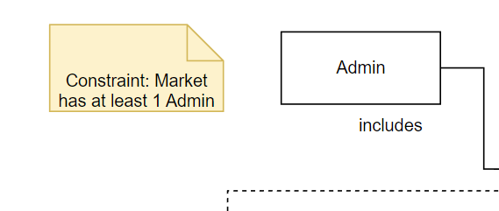

1. *The constraint is enforced in the diagram:*

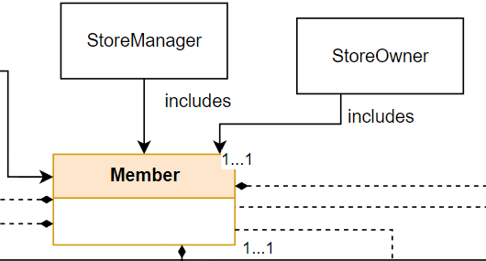

1. *The constraint is enforced in the use case:* ***II.1.1 Enter as a guest.***
2. *The constraint is enforced in the diagram:*

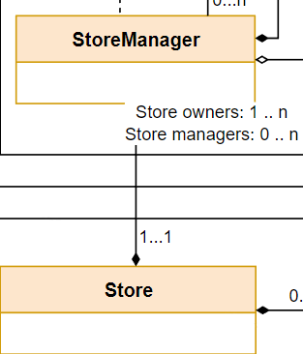

1. *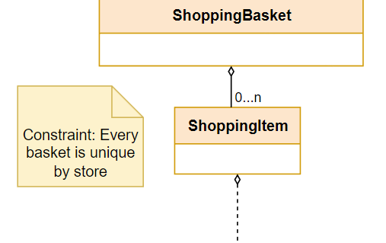The constraint is enforced in the diagram:*
2. *The constraint is enforced in the diagram:*

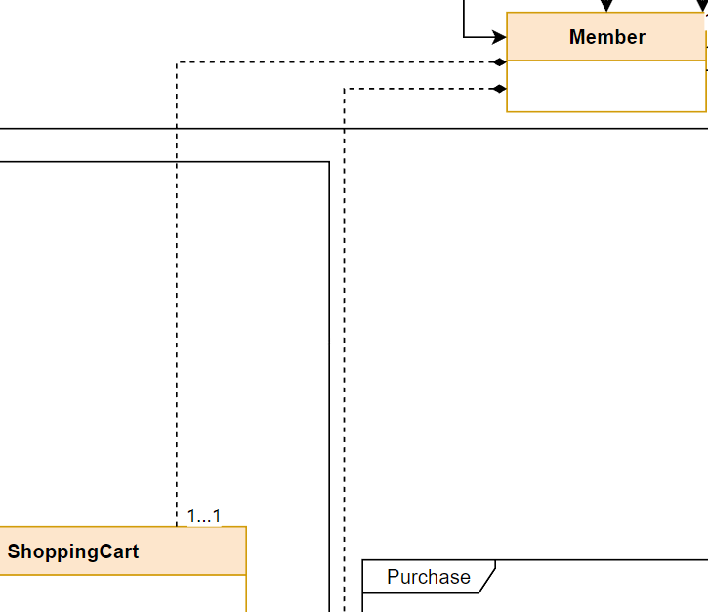

1. *The constraint is enforced in the use case:* ***II.2.5 Purchase a shopping cart.***
2. *The constraint is enforced in the use case:* ***II.2.5 Purchase a shopping cart.***
3. *The constraint is enforced in the diagram:**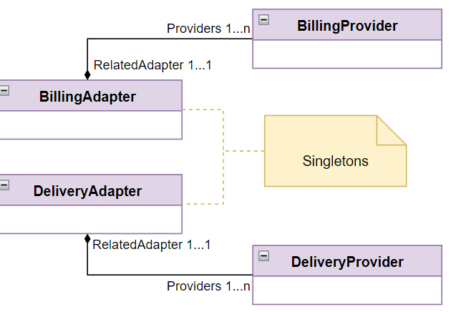*

# 

# Glossary of terms

|  |  |
| --- | --- |
| ***Term*** | ***Definition*** |
| ***User*** | *A general term for a client of the market.* |
| ***Guest*** | *A user who has entered the market system but has not yet logged in.* |
| ***Member*** | *A user who is registered to the market and is currently logged in.* |
| ***Shop founder*** | *A member who created a store.* |
| ***Shop owner*** | *A member who was appointed by an existing owner of the shop and has management permission over the store.* |
| ***Shop manager*** | *A member appointed by a shop owner/shop founder with limited initial permissions.* |
| ***Admin*** | *A member who has authority over the market's management.* |
| ***Market*** | *The market system is an online platform that facilitates trade infrastructure between sellers and buyers.* |
| ***Shopping basket*** | *A shopping basket contains items the user wants to purchase from a specific shop.* |
| ***Shopping cart*** | *A shopping cart contains all the items the user wants to purchase from multiple shops.* |
| ***Purchase policy*** | *Purchase policy defines who is authorized to purchase products in the store and the rules that apply to them. The policy is defined for a store and may apply to products, customers, or both.* |
| ***Discount policy*** | *Discount policy defines who is eligible for a discount and the rules of discount application. The policy is defined for a store and may apply to products, customers, or both.* |
| ***External service*** | *A service given by a third-party company to the market. An external service can refer to an external delivery service or an external payment service.* |
| ***Real-time notification*** | *Real-time notification refers to an immediate alert or message sent to members by the system when a particular event or action requires their attention.* |
| ***Halted notification*** | *A type of notification that is sent to members who were not active on the market during that time. These notifications will be displayed to the member the next time he logs in to the market.* |